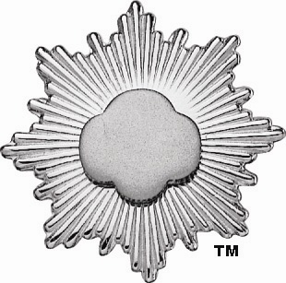

Girl Scout Silver Award Final Report

to (enter your Girl Scout council name)

Please fill out using a word processing program, type, or print in black ink. Make copies for your Girl Scout Silver Award Project Advisor and for yourself to keep. If required, turn in to your Girl Scout council.
Name:

Address: Zip:

Phone: ( ) Your email:

Age: Grade: School:

Troop/Group Advisor: Troop/Group Number:

Troop/Group Advisor’s Phone: ( ) email:

STEP 1: GET READY

Girl Scout Silver Award Project Advisor:

Project Advisor’s Phone: ( ) Project Advisor’s email:

Attach copy of timeline developed by you and your advisor.

STEP 2: GIRL SCOUT SILVER LEADERSHIP AWARD

Activities | Date Completed | Advisor Signature
- Earn It:
IP:
IP:
IP:
- Believe It:
STUDIO 2B Focus book: uniquely Me! The Real Deal
- Lead It: (15 hours) Describe:

STEP 3: GIRL SCOUT SILVER CAREER AWARD
 | Date Completed | Advisor Signature
What’s out there?
Who’s out there?
Your Own Business Interest Project Award

STEP 4: GIRL SCOUT SILVER 4Bs AWARD
Activity | Date Completed | Advisor Signature
- Become:
- Belong:
STUDIO 2B Focus Book: Looking In, Reaching Out
- Believe Issue: How did you use your voice?

- Build: Describe your solution:

STEP 5: GIRL SCOUT SILVER AWARD PROJECT

Title of Project:

Start date: Completion date:

- Describe the issue your project addressed, what you achieved, and who benefited.

- Discuss the reasons for selecting this project.

- Outline your strengths, talents, and skills that you put into action.

- Describe the steps involved for putting your plan into action, including facilities and/or equipment needed. (You can attach project plan.)

- Indicate methods and/or tools utilized to evaluate the effectiveness of your project?

- List the consultants and resources you used.

- Overall project expenses and how you met these costs (attach copy of budget sheet from your record book).

Your signature: _____________________________________ Date:
Project Advisor’s Signature: _______________________________________________
ACTIONS: | DATE:
Approved by Girl Scout Project Advisor:
Awarded Girl Scout Silver Award:

